***CENTRAL CALCUTTA POLYTECHNIC***

**ASSIGNMENT**

**2020-21**



❖NAME: Sourav Bhunia

❖DEPERTMENT: CST (3rd Sem)

❖ROLL: DCCPCSTS3 NO.:10005529

❖REGISTRATION NO.: D192005234

❖PROJECT ON: ‘C' PROGRAMMING

|  |  |  |  |
| --- | --- | --- | --- |
| SL.NO | ‘C’ PROGRAMMING PROBLEM | PAGE  NO | TEACHER  SIGNATURE |
| 01 | Write a C program to find maximum between two numbers. |  |  |
| 02 | Write a C program to find maximum between three numbers. |  |  |
| 03 | Write a C program to check whether a number is negative, positive or zero. |  |  |
| 04 | Write a C program to check whether a number is divisible by 5 and 11 or not. |  |  |
| 05 | Write a C program to check whether a number is even or odd. |  |  |
| 06 | Write a C program to check whether a year is leap year or not. |  |  |
| 07 | Write a C program to check whether a character is alphabet or not. |  |  |
| 08 | Write a C program to input any alphabet and check whether it is vowel or consonant. |  |  |
| 09 | Write a C program to input any character and check whether it is alphabet, digit or special character. |  |  |
| 10 | Write a C program to check whether a character is uppercase or lowercase alphabet. |  |  |
| 11 | Write a C program to input week number and print week day. |  |  |
| 12 | Write a C program to input month number and print number of days in that month. |  |  |
| 13 | Write a C program to count total number of notes in given amount. |  |  |
| 14 | Write a C program to input angles of a triangle and check whether triangle is valid or not. |  |  |
| 15 | Write a C program to input all sides of a triangle and check whether triangle is valid or not. |  |  |
| 16 | Write a C program to check whether the triangle is equilateral, isosceles or scalene triangle. |  |  |
| 17 | Write a C program to find all roots of a quadratic equation. |  |  |
| 18 | Write a C program to calculate profit or loss. |  |  |
| 19 | Write a C program to input marks of five subjects Physics, Chemistry, Biology, Mathematics and Computer. Calculate percentage and grade according to following:  Percentage >= 90% : Grade A  Percentage >= 80% : Grade B  Percentage >= 70% : Grade C  Percentage >= 60% : Grade D  Percentage >= 40% : Grade E  Percentage < 40% : Grade F |  |  |
| 20 | Write a C program to input basic salary of an employee and calculate its Gross salary according to following:  Basic Salary <= 10000 : HRA = 20%, DA = 80%  Basic Salary <= 20000 : HRA = 25%, DA = 90%  Basic Salary > 20000 : HRA = 30%, DA = 95% |  |  |
| 21 | Write a C program to input electricity unit charges and calculate total  electricity bill according to the given condition:  For first 50 units Rs. 0.50/unit  For next 100 units Rs. 0.75/unit  For next 100 units Rs. 1.20/unit  For unit above 250 R.S 1.50/uni An additional surcharge of 20% is added to the bill |  |  |

1. Write a C program to find maximum between two numbers.

INPUT CODE:

#include <stdio.h>

int main(){

int a,b;

printf("Enter any two number:\n");

scanf("%d%d", &a,&b);

if (a>b)

{

printf("%d is greater than %d", a,b);

}

else if (b>a)

{

printf("%d is greater than %d", b,a);

}

else

{

printf("%d and %d is same number", a,b);

}

return 0;

}

OUTPUT:

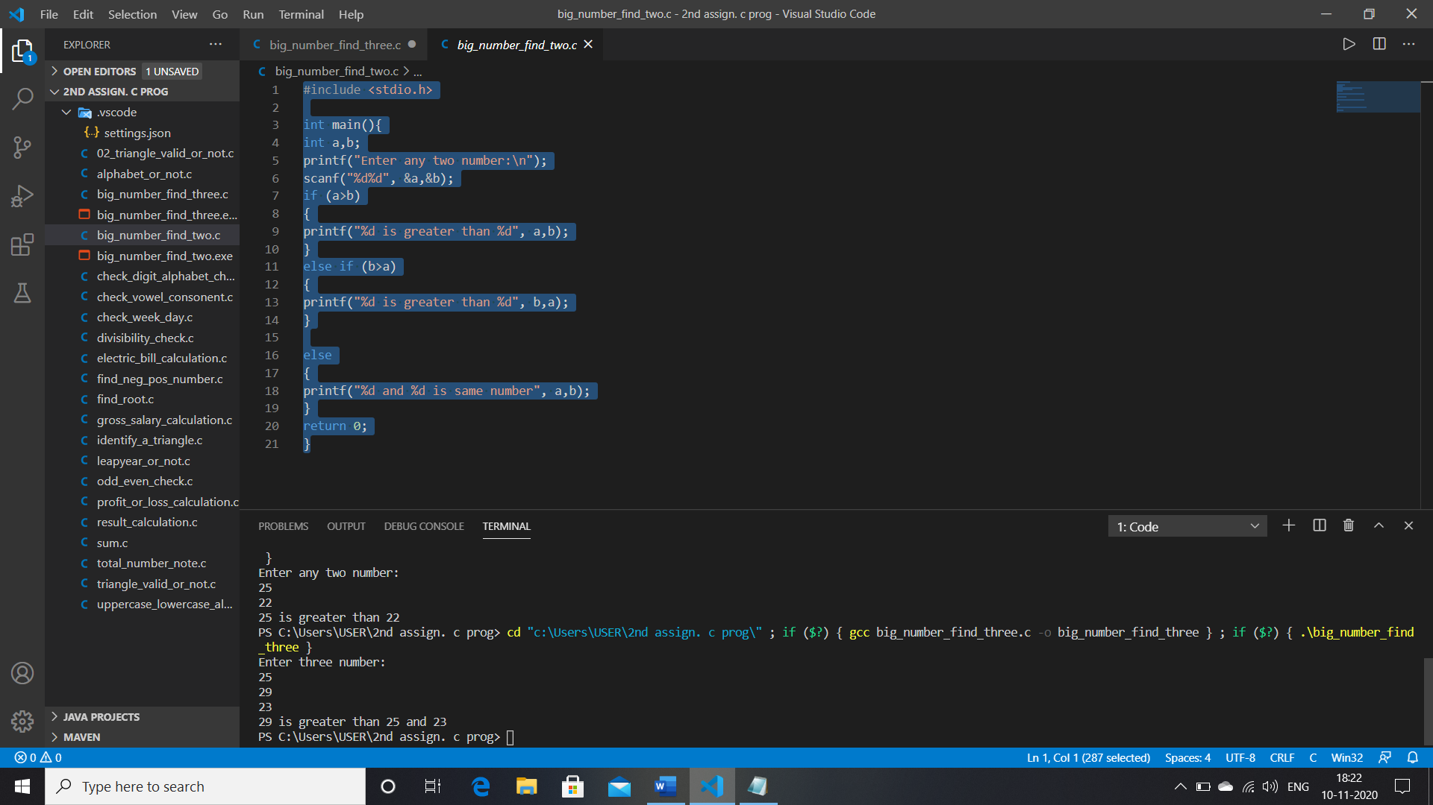

1. Write a C program to find maximum between three numbers.

INPUT CODE:

#include <stdio.h>

int main(){

int a,b,c;

printf("Enter three number:\n");

scanf("%d%d%d", &a,&b,&c);

if (a>b && a>c)

{

printf("%d is greater than %d and %d\n", a,b,c);

}

else if (b>a && b>c)

{

printf("%d is greater than %d and %d\n", b,a,c);

}

else if(c>a && c>b){

printf("%d is greater than %d and %d\n", c,b,a);

}

else{

printf("Any two or three number is same.\n");

}

return 0;

}

OUTPUT:

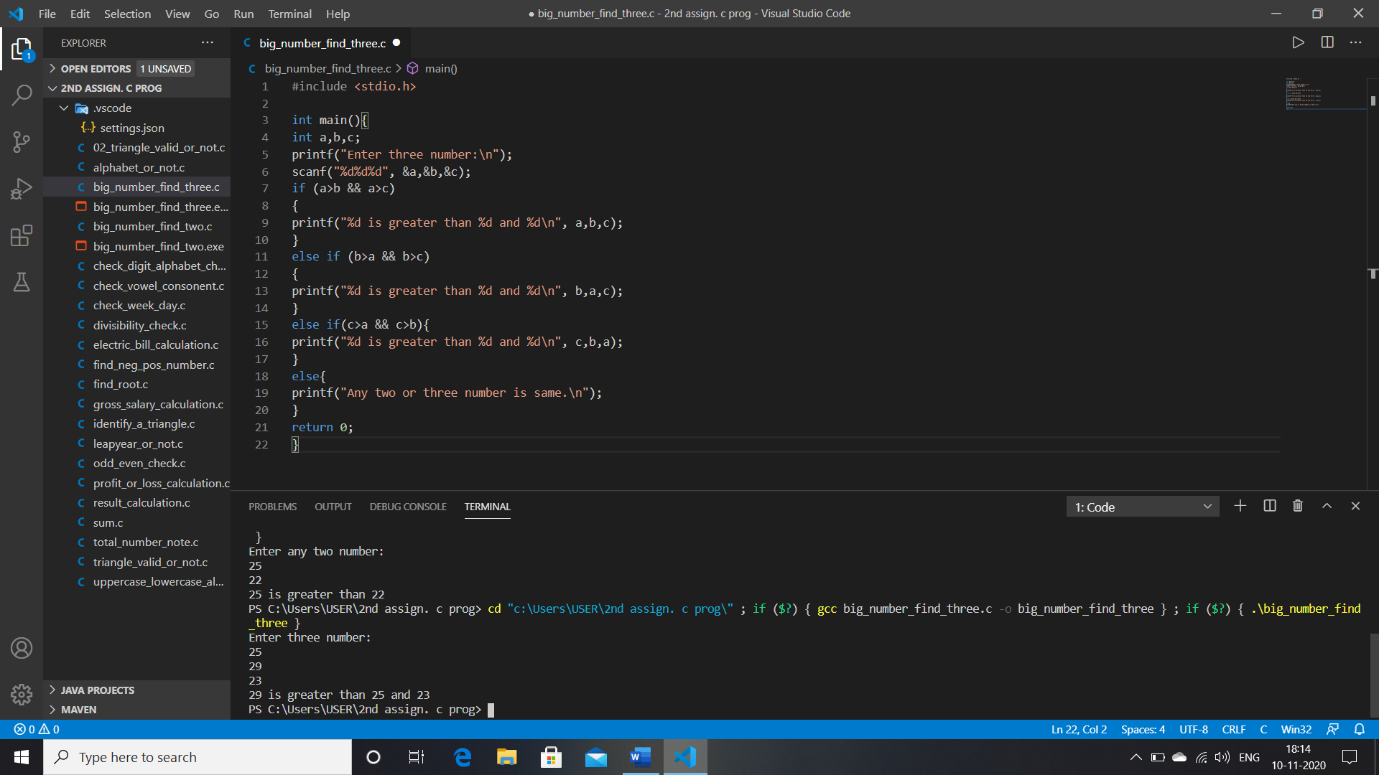

3. Write a C program to check whether a number is negative, positive or zero.

INPUT CODE:

#include <stdio.h>

int main(){

int a;

printf("Enter a number:\n");

scanf("%d", &a);

if(a>0){

printf("The number %d is positive.\n", a);

}

else if(a<0){

printf("The number %d is negative.\n", a);

}

else

{

printf("The number %d is Zero.\n", a);

}

return 0;

}

OUTPUT:

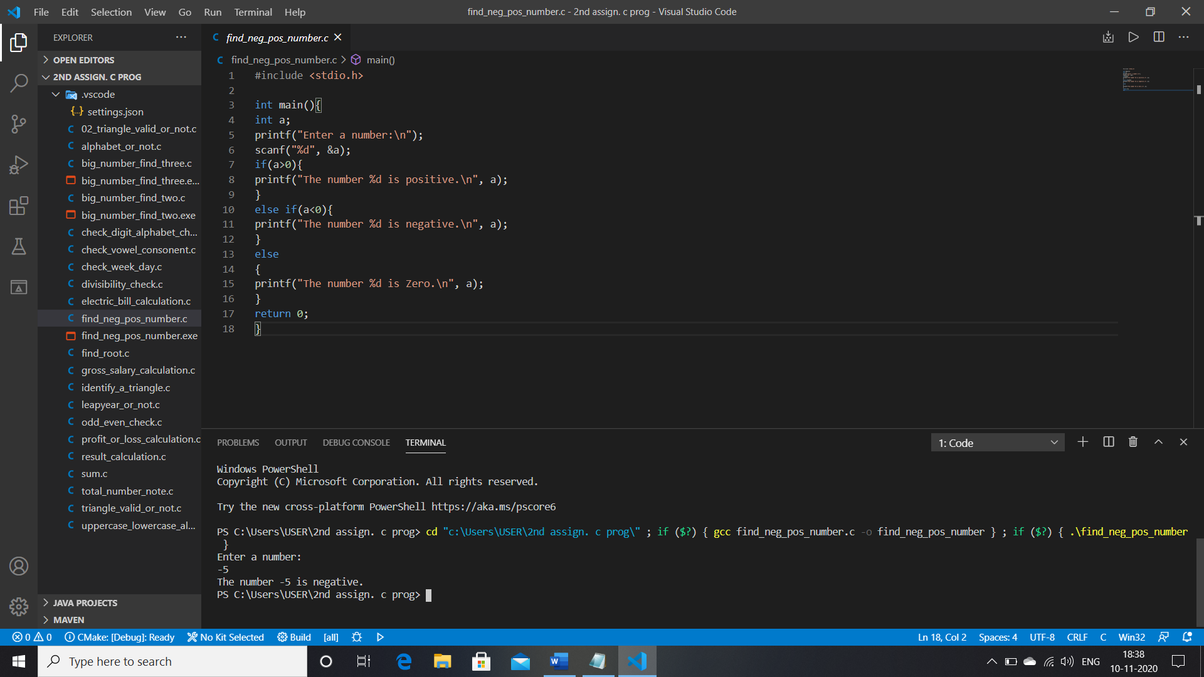

4. Write a C program to check whether a number is divisible by 5 and 11 or not.

INPUT CODE:

#include <stdio.h>

int main(){

int A;

printf("Enter a number:\n");

scanf("%d", &A);

if (A%5==0)

{

printf("The number %d is divisible by 5.\n", A);

}

else if (A%11==0)

{

printf("The number %d is divisible by 11.\n", A);

}

else

{

printf("The number %d is not divisible by 5 or11.\n", A);

}

return 0;

}

OUTPUT:

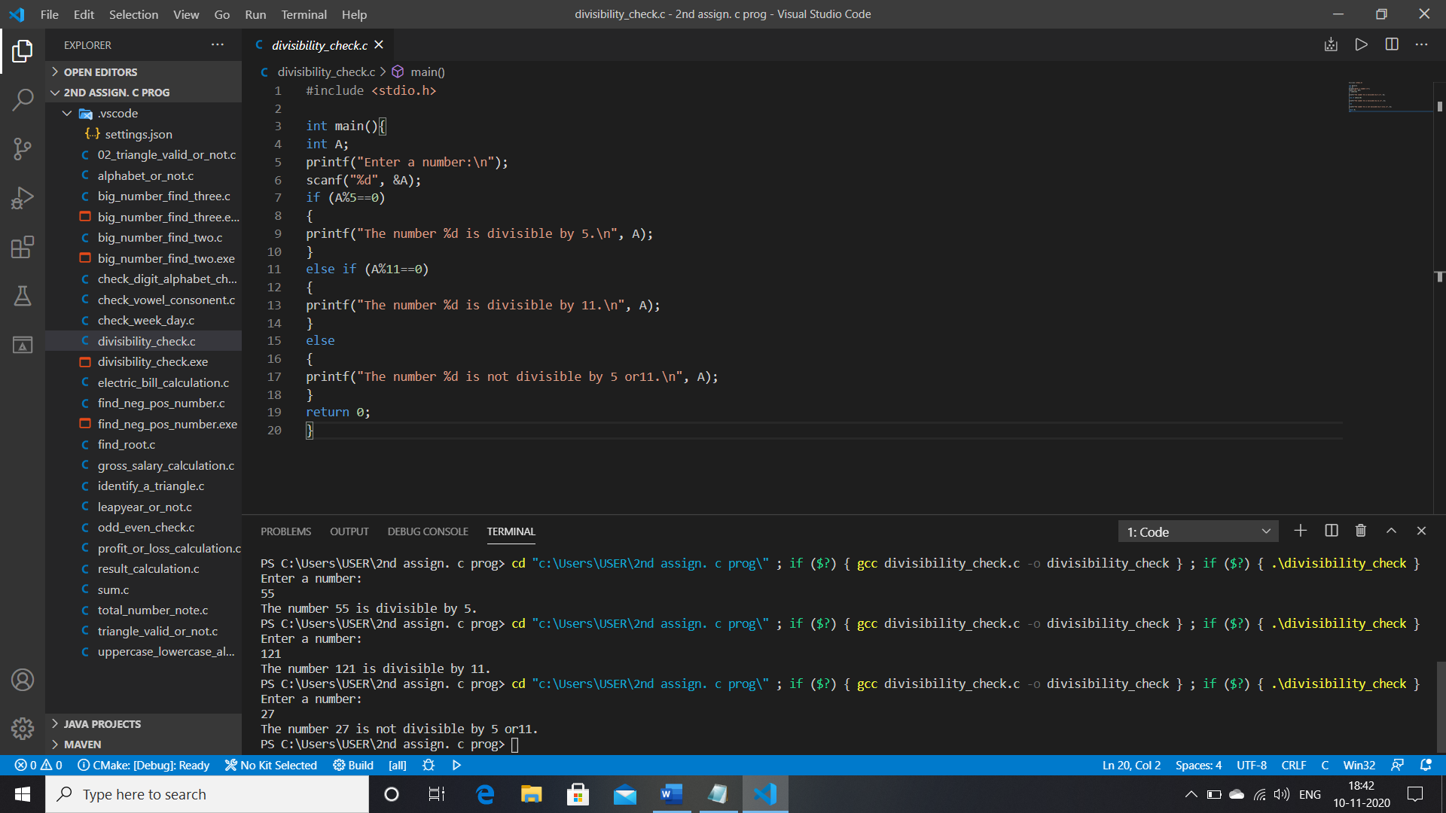

5. Write a C program to check whether a number is even or odd.

INPUT CODE:

#include <stdio.h>

int main(){

int A;

printf("Enter a number:\n");

scanf("%d", &A);

if (A%2==0)

{

printf("The number %d is even.\n",A);

}

else

{

printf("The number %d is odd.\n",A);

}

return 0;

}

OUTPUT:

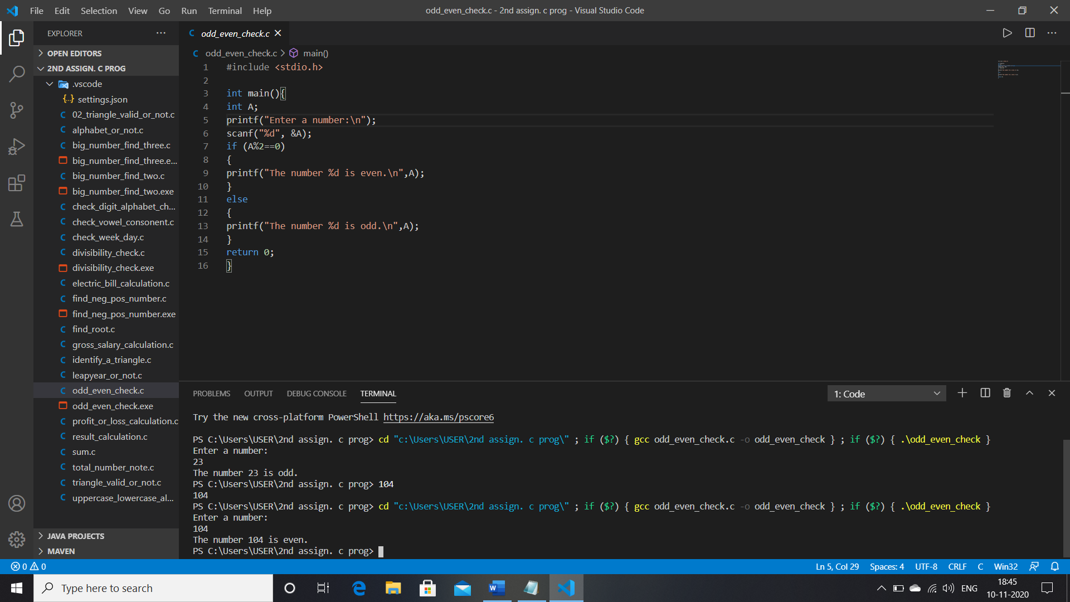

6. Write a C program to check whether a year is leap year or not.

INPUT CODE:

#include <stdio.h>

int main(){

int a;

printf("Enter the year:\n");

scanf("%d", &a);

if (a%100==0)

{

printf("This is a century year.\n");

if (a%400==0)

{

printf("This is a leapyear.\n");

}

else

{

printf("This is a not leapyear.\n");

}

}

else if (a%4==0)

{

printf("This is a not century but leapyear.\n");

}

else

{

printf("This is a not leapyear.\n");

}

return 0;

}

OUTPUT:

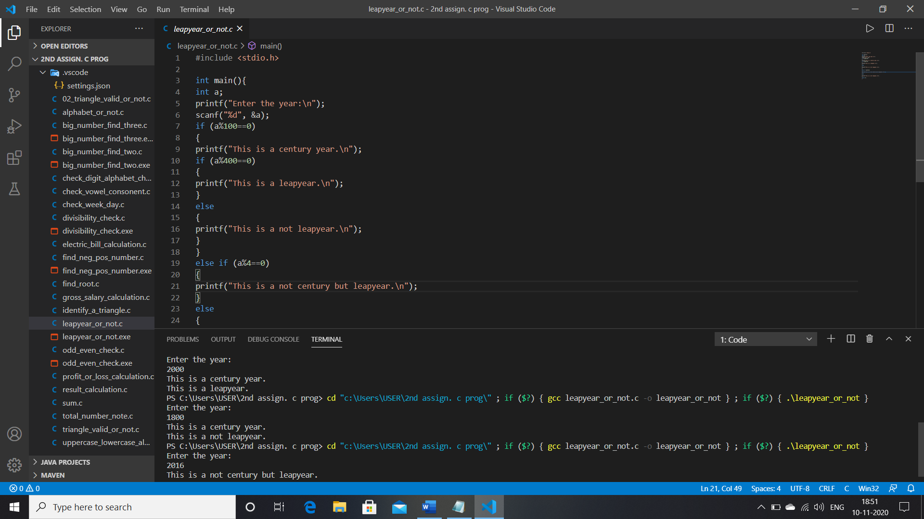

7. Write a C program to check whether a character is alphabet or not.

INPUT CODE:

#include <stdio.h>

int main(){

char a;

printf("Enter a character:\n");

scanf("%c", &a);

if ((a>=65 && a<=90)||(a>=97 && a<=122))

{

printf("The cheracter is a alphabet.\n");

}

else

{

printf("The cheracter is not a alphabet.\n");

}

return 0;

}

OUTPUT:

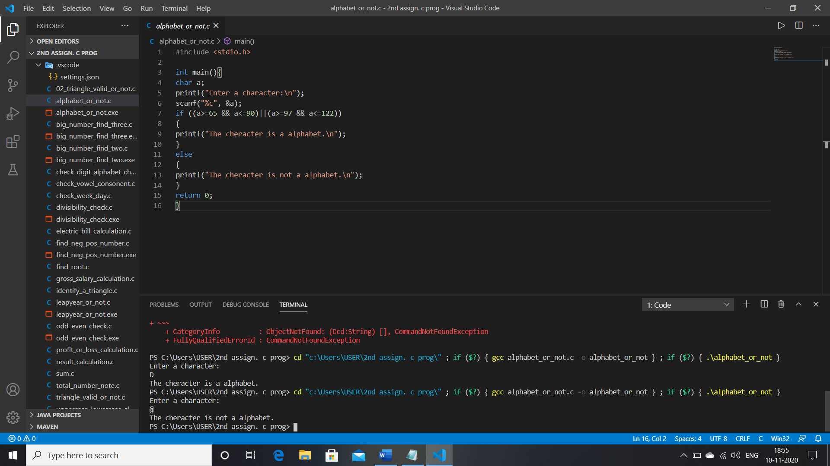

8. Write a C program to input any alphabet and check whether it is vowel or consonant.

INPUTCODE:

#include <stdio.h>

int main(){

char a;

printf("Enter a character:\n");

scanf("%c", &a);

if((a>=65 && a<=90)||(a>=97 && a<=122)){

printf("This ia a alphabet.\n");

if (a==65 || a==69 || a==73 || a==79 || a==85 || a==97 || a==101 || a==105 || a==111 || a==117 ){

printf("Vowel\n");

}

else{

printf("Consonant\n");

}

}

else{

printf("This character is not a alphabet.\n");

}

return 0;

}

OUTPUT:

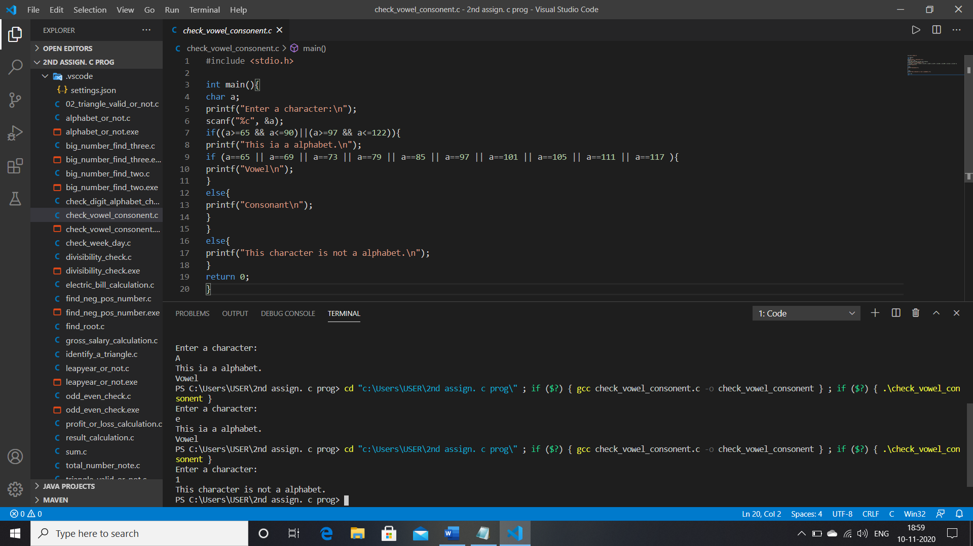

9. Write a C program to input any character and check whether it is alphabet, digit or special character.

INPUT CODE:

#include <stdio.h>

int main(){

char a;

printf("Enter a character:\n");

scanf("%c", &a);

if (((a>=65 && a<=90)||(a>=97 && a<=122))){

printf("The character is a alphabet.\n");

}

else if(a>=48 && a<=57){

printf("The character is a digit.\n");

}

else{

printf("The character is a special character.\n");

}

return 0;

}

OUTPUT:

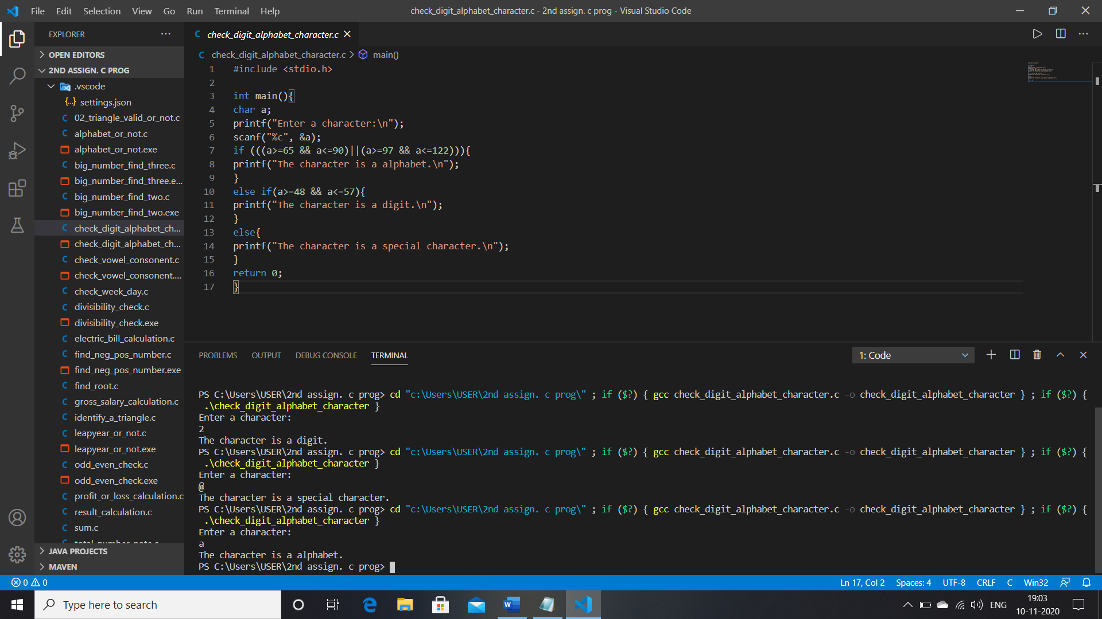

10. Write a C program to check whether a character is uppercase or lowercase alphabet.

INPUT CODE:

#include <stdio.h>

int main(){

char a;

printf("Enter a character:\n");

scanf("%c", &a);

if (a>=65 && a<=90){

printf("This is a uppercase alphabet.\n");

}

else if(a>=97 && a<=122){

printf("This is a lowercase alphabet.\n");

}

else{

printf("This is not a alphabet.\n");

}

return 0;

}

OUTPUT:

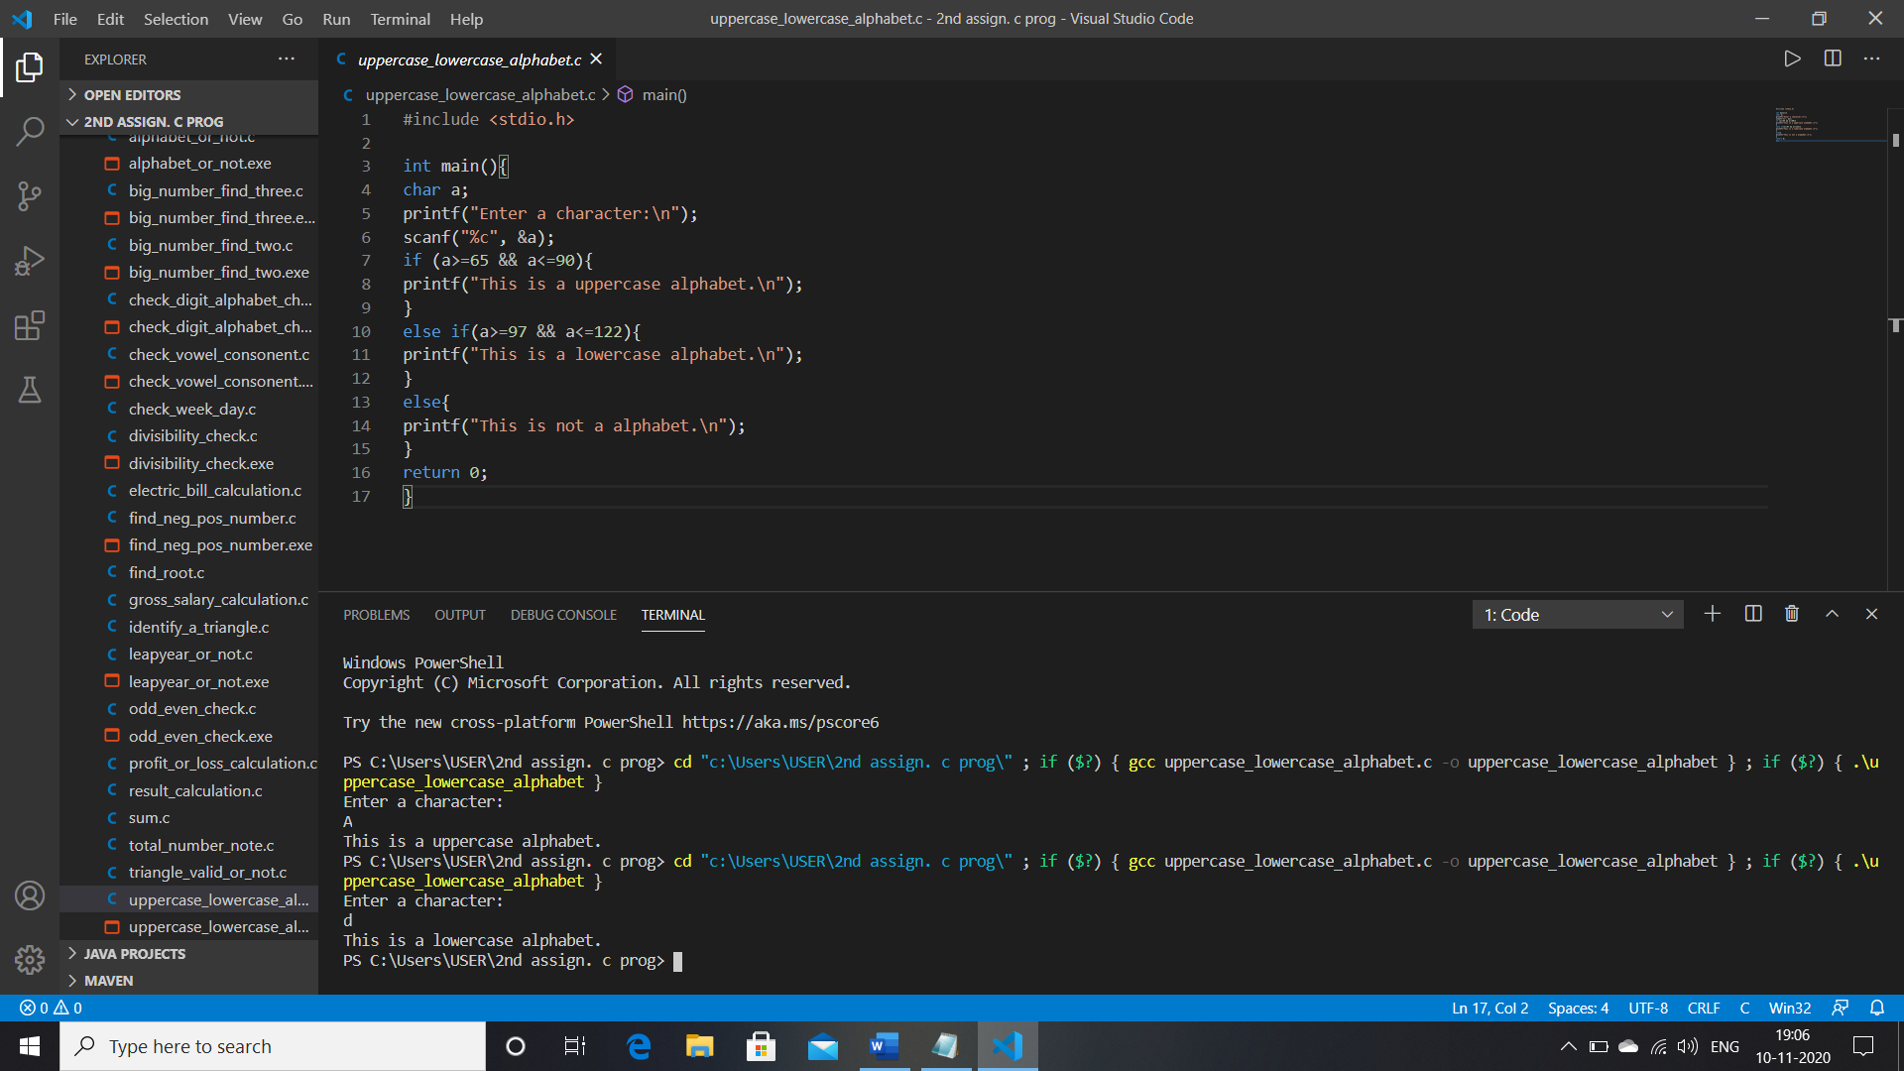

11. Write a C program to input week number and print week day.

INPUT CODE:

#include <stdio.h>

int main(){

int a;

printf("Enter a week number:\n");

scanf("%d", &a);

switch (a){

case 1:

printf("sunday");

    break;

case 2:

printf("Monday");

    break;

case 3:

printf("Tuesday");

    break;

case 4:

printf("Wednesday");

    break;

case 5:

printf("Thusday");

    break;

case 6:

printf("Friday");

    break;

case 7:

printf("saturday");

    break;

default:

printf("Invalid day.");

    break;

}

return 0;

}

OUTPUT:

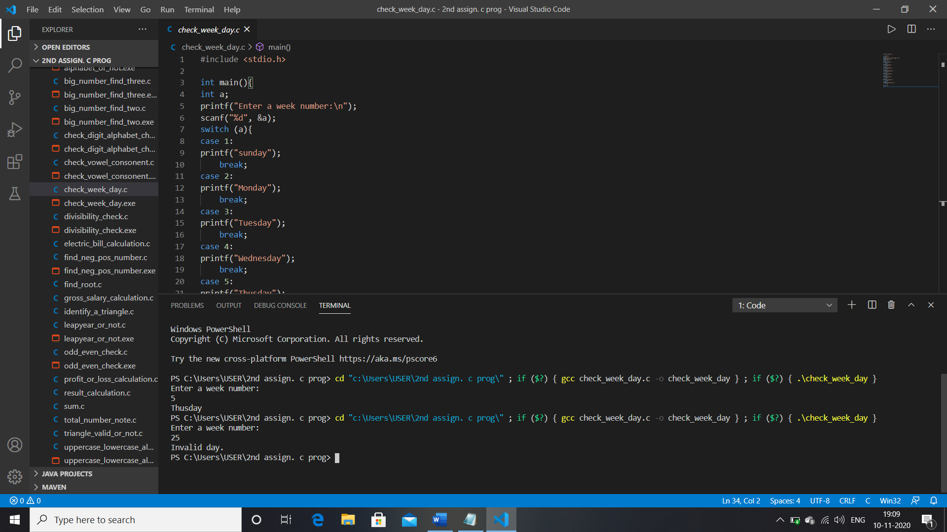

13. Write a C program to count total number of notes in given amount.

INPUT CODE:

#include <stdio.h>

int main(){

int Balance;

int note2000,note500,note200,note100,note50,note20,note10,note5,note2,note1;

printf("Enter your amount: ");

scanf("%d", &Balance);

note2000 = note500 = note100 = note50 = note20 = note10 = note5 = note2 = note1 = 0;

if (Balance>=2000)

{

note2000=Balance/2000;

Balance -=note2000*2000;

}

if (Balance>=500)

{

note500=Balance/500;

Balance -=note500*500;

}

if (Balance>=200)

{

note200=Balance/200;

Balance -=note200*200;

}

if (Balance>=50)

{

note50=Balance/50;

Balance -=note50*50;

}

if (Balance>=20)

{

note20=Balance/20;

Balance -=note20*20;

}

if (Balance>=20)

{

note20=Balance/20;

Balance -=note20*20;

}

if (Balance>=10)

{

note10=Balance/10;

Balance -=note10*10;

}

if (Balance>=5)

{

note5=Balance/5;

Balance -=note5*5;

}

if (Balance>=2)

{

note2=Balance/2;

Balance -=note2*2;

}

if (Balance>=1)

{

note1=Balance;

}

printf("Total number of notes = \n");

printf("2000 = %d\n", note2000);

printf("500 = %d\n", note500);

printf("200 = %d\n", note200);

printf("100 = %d\n", note100);

printf("50 = %d\n", note50);

printf("20 = %d\n", note20);

printf("10 = %d\n", note10);

printf("5 = %d\n", note5);

printf("2 = %d\n", note2);

printf("1 = %d\n", note1);

return 0;

}

OUTPUT:

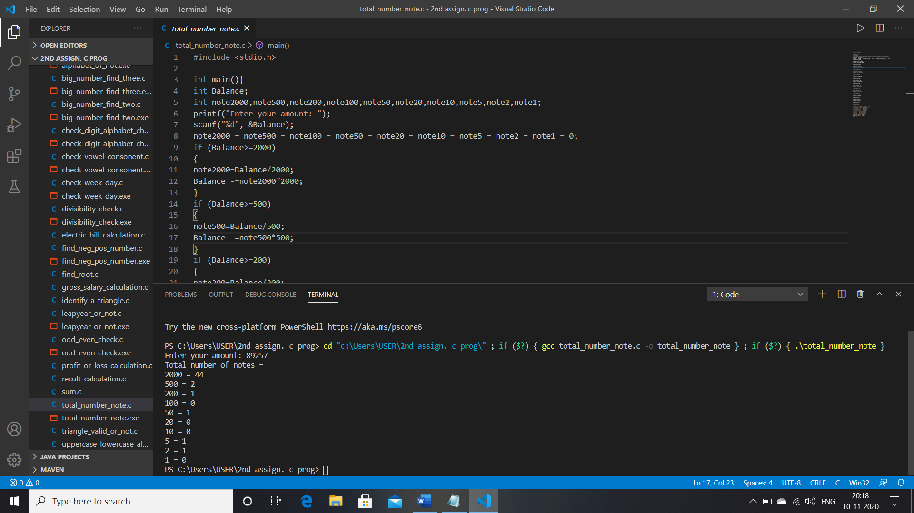

14. Write a C program to input angles of a triangle and check whether triangle is valid or not.

INPUT CODE:

#include <stdio.h>

int main(){

int A,B,C;

printf("Enter three angle of a tringle:\n");

scanf("%d%d%d", &A,&B,&C);

if (A+B+C==180)

{

printf("This is a valid triangle.");

}

else{

printf("This is not a valid triangle.");

}

return 0;

}

OUTPUT:

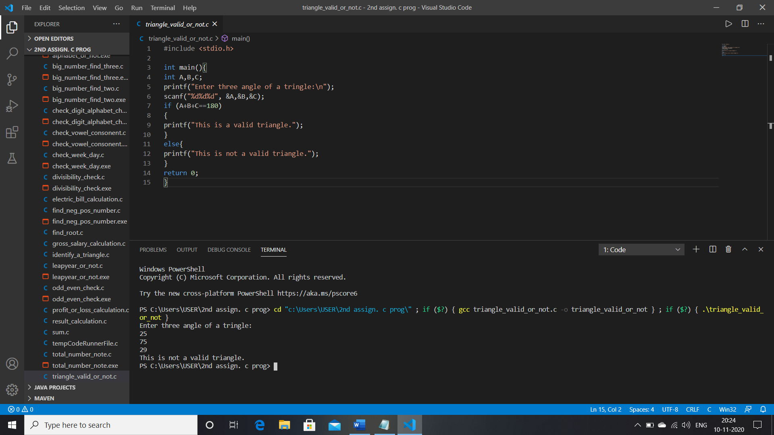

15. Write a C program to input all sides of a triangle and check whether triangle is valid or not.

INPUT CODE:

#include <stdio.h>

int main(){

int S1,S2,S3;

printf("Enter three side of this triangle: \n");

scanf("%d%d%d", &S1,&S2,&S3);

if ((S1+S2>S3)&&(S2+S3>S1)&&(S3+S1>S2)){

printf("This is a valid triangle.");

}

else{

printf("This is not a valid triangle.");

}

return 0;

}

OUTPUT:

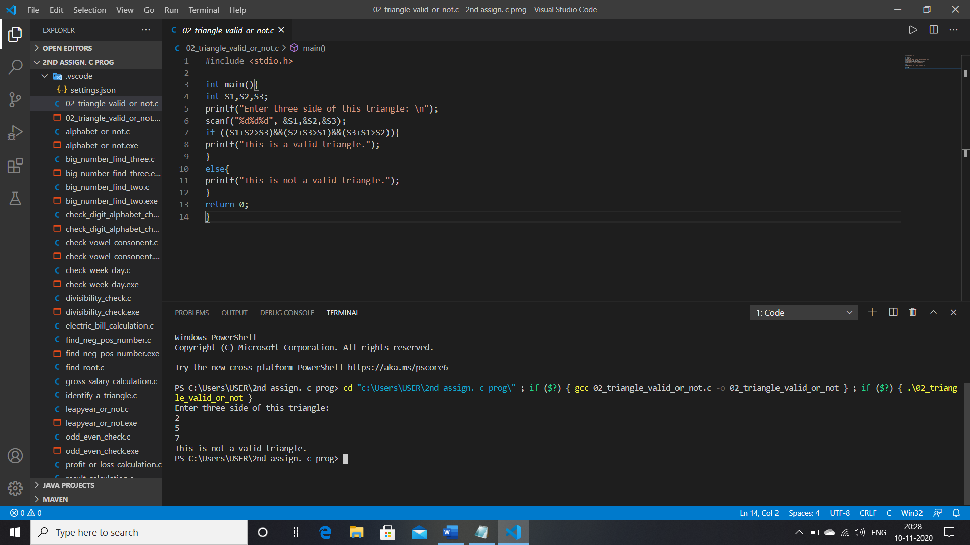

16. Write a C program to check whether the triangle is equilateral, isosceles or scalene triangle.

INPUT CODE:

#include <stdio.h>

int main(){

int S1,S2,S3;

printf("Enter three sides of the triangle: \n");

scanf("%d%d%d",&S1,&S2,S3);

if (S1==S2==S3){

printf("Tis is a equilateral triangle. \n");

}

else if (S1==S2 || S2==S3 || S3==S1){

printf("This is a isosceles triangle. \n");

}

else if (S1!=S2!=S3){

printf("This is a scalene triangle. \n");

}

return 0;

}

OUTPUT:

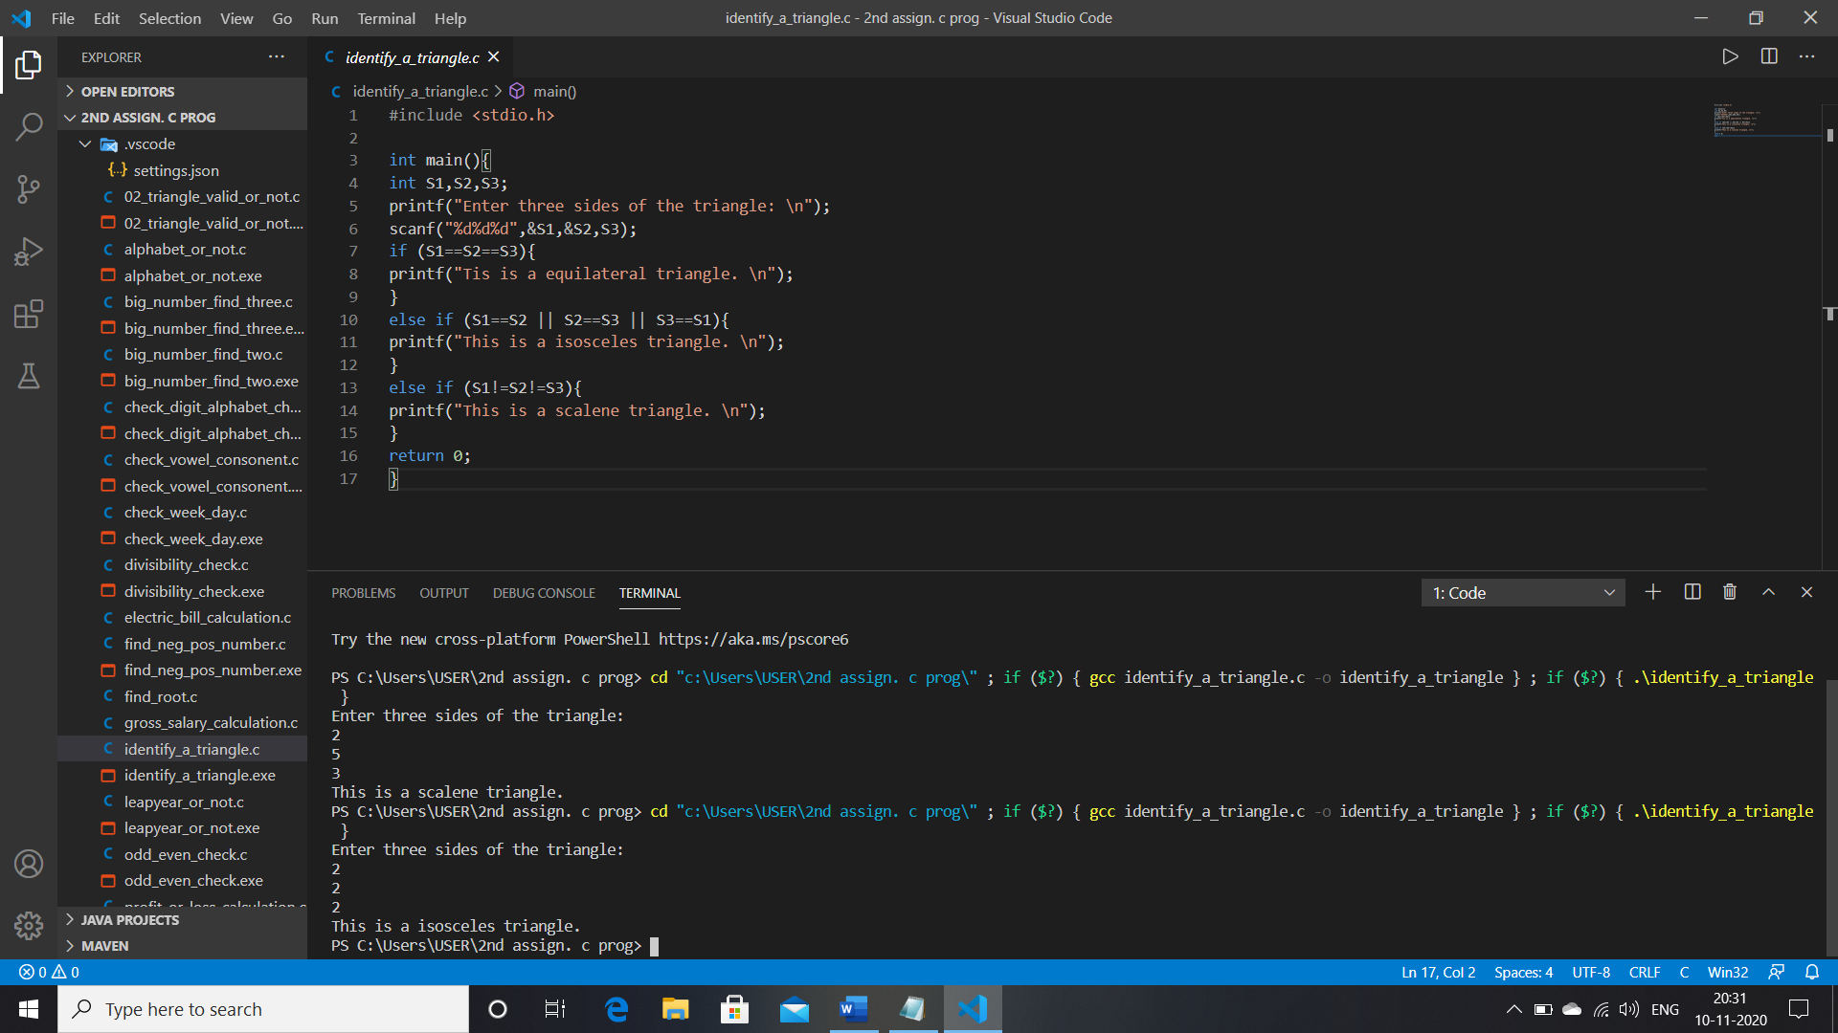

17. Write a C program to find all roots of a quadratic equation.

INPUT CODE:

#include <math.h>

#include <stdio.h>

int main() {

    double a, b, c, discriminant, root1, root2, realPart, imagPart;

    printf("Enter coefficients a, b and c: ");

    scanf("%lf %lf %lf", &a, &b, &c);

    discriminant = b * b - 4 * a * c;

    if (discriminant > 0) {

        root1 = (-b + sqrt(discriminant)) / (2 * a);

        root2 = (-b - sqrt(discriminant)) / (2 * a);

        printf("root1 = %.2lf and root2 = %.2lf", root1, root2);

    }

    else if (discriminant == 0) {

        root1 = root2 = -b / (2 * a);

        printf("root1 = root2 = %.2lf;", root1);

    }

    else {

        realPart = -b / (2 * a);

        imagPart = sqrt(-discriminant) / (2 * a);

        printf("root1 = %.2lf+%.2lfi and root2 = %.2f-%.2fi", realPart, imagPart, realPart, imagPart);

    }

    return 0;

}

OUTPUT:

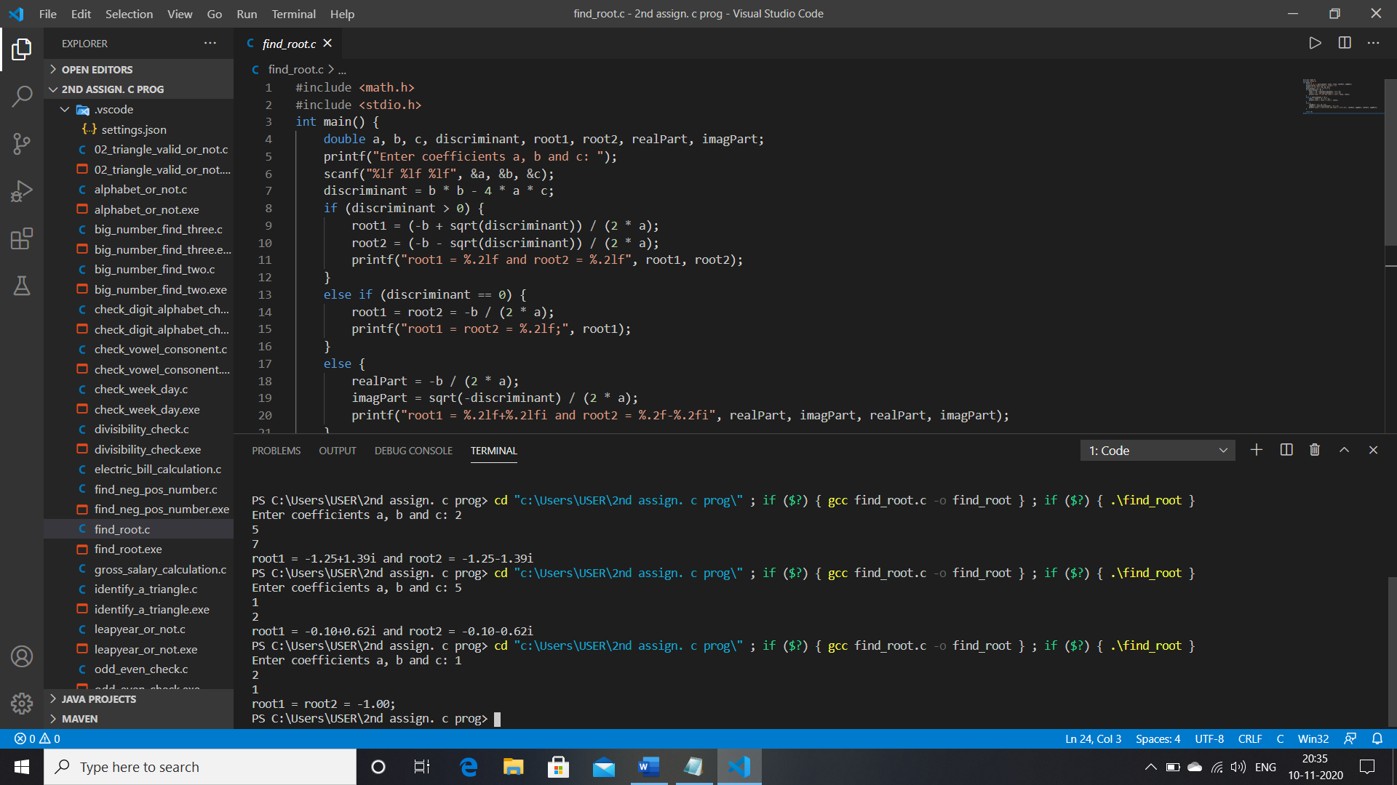

18. Write a C program to calculate profit or loss.

INPUT CODE:

#include <stdio.h>

int main(){

float SP,cost,percentage;

printf("Enter cost of the product: \n");

scanf("%f", &cost);

printf("Enter Selling price of the product: \n");

scanf("%f", &SP);

if (SP>cost){

percentage = ((SP-cost)/cost)*100;

printf("Profit in percentage: %0.2f", percentage);

}

else if (cost>SP){

percentage = ((cost-SP)/cost)*100;

printf("Loss in percentage: %0.2f", percentage);

}

return 0;

}

OUTPUT:

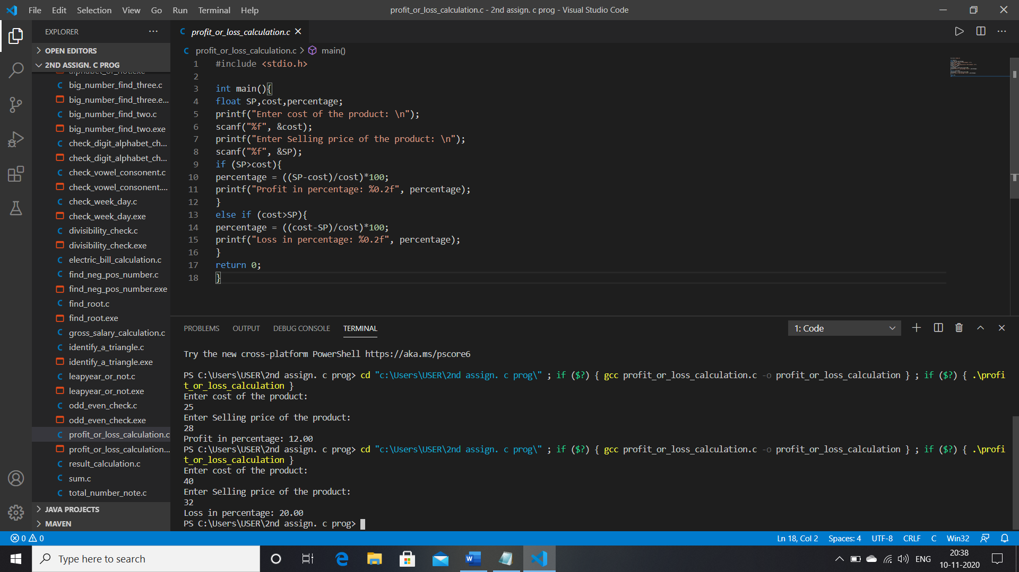

19. Write a C program to input marks of five subjects Physics, Chemistry, Biology, Mathematics and Computer. Calculate percentage and grade according to following:

Percentage >= 90% : Grade A

Percentage >= 80% : Grade B

Percentage >= 70% : Grade C

Percentage >= 60% : Grade D

Percentage >= 40% : Grade E

Percentage < 40% : Grade F

**INPUT CODE**:

#include <stdio.h>

int main(){

int P,C,M,B,Cs;

float percentage;

printf("Enter your obtaining marks in Physics, Chemistry, Mathematics, Biology, Computer Science: \n");

scanf("%d%d%d%d%d", &P,&C,&M,&B,&Cs);

percentage = ((P+C+M+B+Cs)/500.0)*100;

printf("Percentage= %.2f\n", percentage);

if (percentage >=90 && percentage <=100){

printf("Grade: AA");

}

else if (percentage >=80 && percentage <=89){

printf("Grade: A+");

}

else if (percentage >=70 && percentage <=79){

printf("Grade: A");

}

else if (percentage >=60 && percentage <=69){

printf("Grade: B+");

}

else if (percentage >=50 && percentage <=59){

printf("Grade: B");

}

else if (percentage >=35 && percentage <=49){

printf("Grade: C");

}

else if (percentage >=0 && percentage <=34){

printf("Grade: D");

}

return 0;

}

**OUTPUT:**

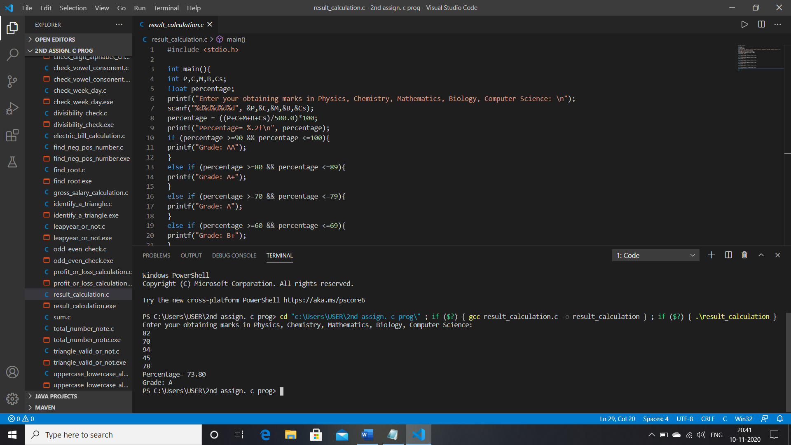

20. Write a C program to input basic salary of an employee and calculate its Gross salary according to following:

Basic Salary <= 10000 : HRA = 20%, DA = 80%

Basic Salary <= 20000 : HRA = 25%, DA = 90%

Basic Salary > 20000 : HRA = 30%, DA = 95%

**INPUT CODE:**

#include <stdio.h>

int main(){

float salary,g_salary;

printf("Enter your basic salary: \n");

scanf("%f", &salary);

if (salary >= 0 && salary <= 10000){

g_salary = salary+(salary*0.2)+(salary*0.8);

printf("Gross salary: %0.2f\n", g_salary);

}

else if (salary > 10000 && salary <=20000){

g_salary = salary+(salary*0.25)+(salary*0.9);

printf("Gross salary: %0.2f\n", g_salary);

}

else if (salary > 20000){

g_salary = salary+(salary*0.3)+(salary*0.95);

printf("Gross salary: %0.2f\n", g_salary);

}

return 0;

}

**OUTPUT:**

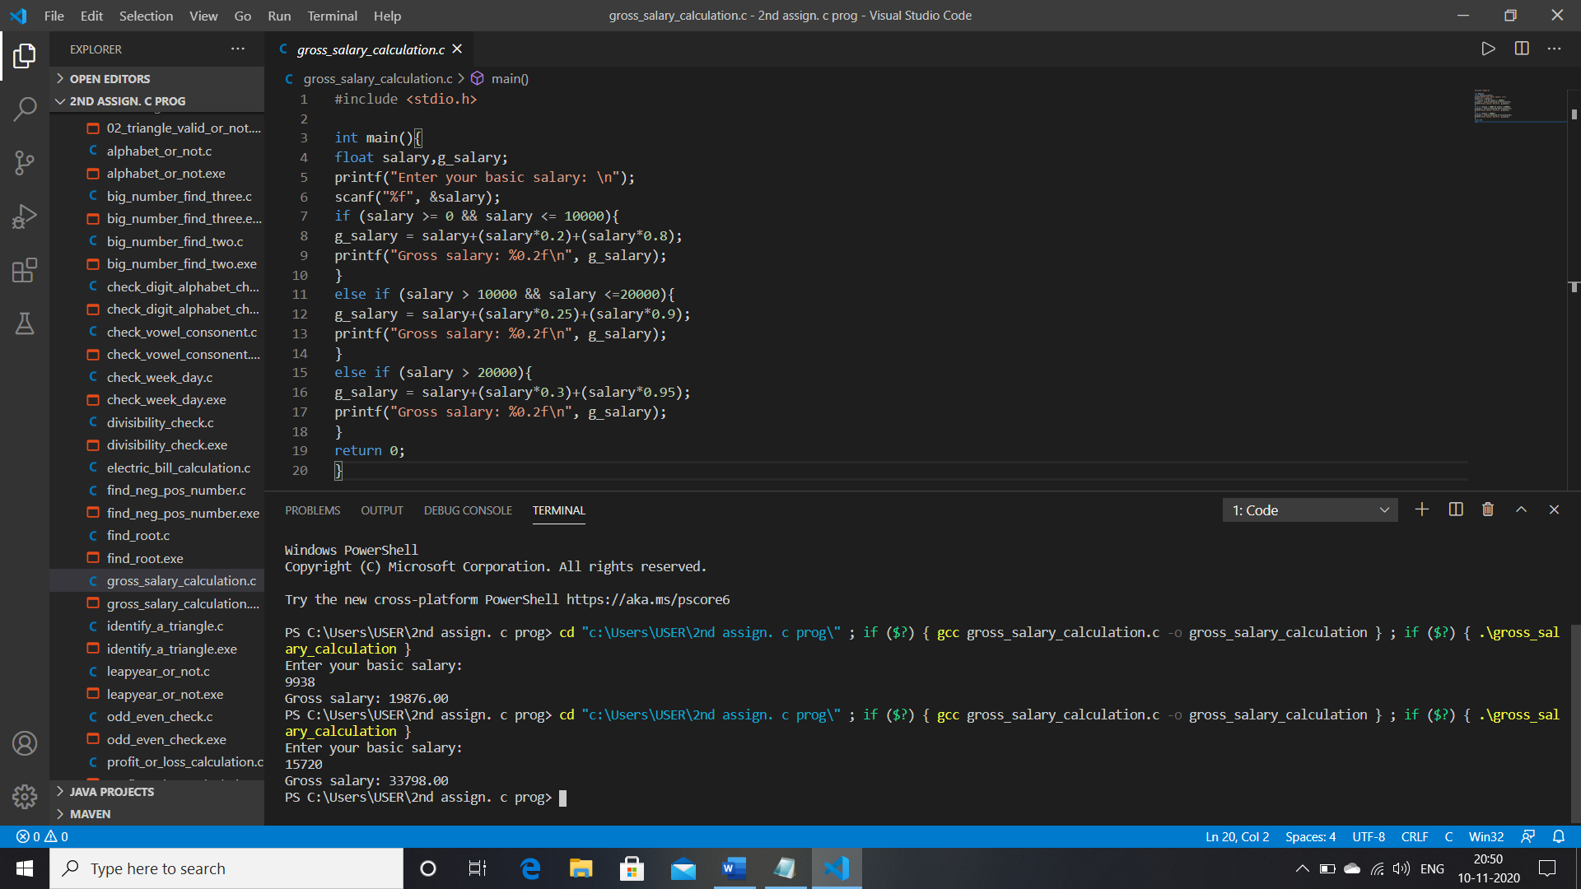

21. Write a C program to input electricity unit charges and calculate total electricity bill according to the given condition:

For first 50 units Rs. 0.50/unit

For next 100 units Rs. 0.75/unit

For next 100 units Rs. 1.20/unit

For unit above 250 Rs. 1.50/unit

An additional surcharge of 20% is added to the bill

**INPUT CODE:**

#include <stdio.h>

int main(){

int unit;

float bill,total_bill,sur_charge;

printf("Enter total consumed; \n");

scanf("%d", &unit);

if (unit>=0 && unit<=50){

bill = unit*0.5;

sur_charge = bill*0.2;

total_bill = bill+sur_charge;

}

else if (unit>50 && unit<=150){

bill = (50*0.5)+((unit-50)*0.75);

sur_charge = bill*0.2;

total_bill = bill+sur_charge;

}

else if (unit>150 && unit<=250){

bill = (50*0.5)+(100*0.75)+((unit-150)*1.20);

sur_charge = bill*0.2;

total_bill = bill+sur_charge;

}

else if (unit>250){

bill = (50*0.5)+(100*0.75)+(100*1.20)+((unit-250)*1.50);

sur_charge = bill*0.2;

total_bill = bill+sur_charge;

}

printf("Total payable amount: %0.2f\n", total_bill);

return 0;

}

**OUTPUT:**

